

# Build And Release Management Lab

**Submitted by: Submitted to:**

**NAME : Anmol yadav Dr. Hitesh Kumar Sharma**

**SAP: 500083814**

**ROLL NO.: R214220178**

**BATCH: 1 DevOps**

**LAB EXERCISE 10**

**Aim: Integration using GitHub**

Create a complete Maven project and push in GitHub repository for Continuous Integration.

First create project:

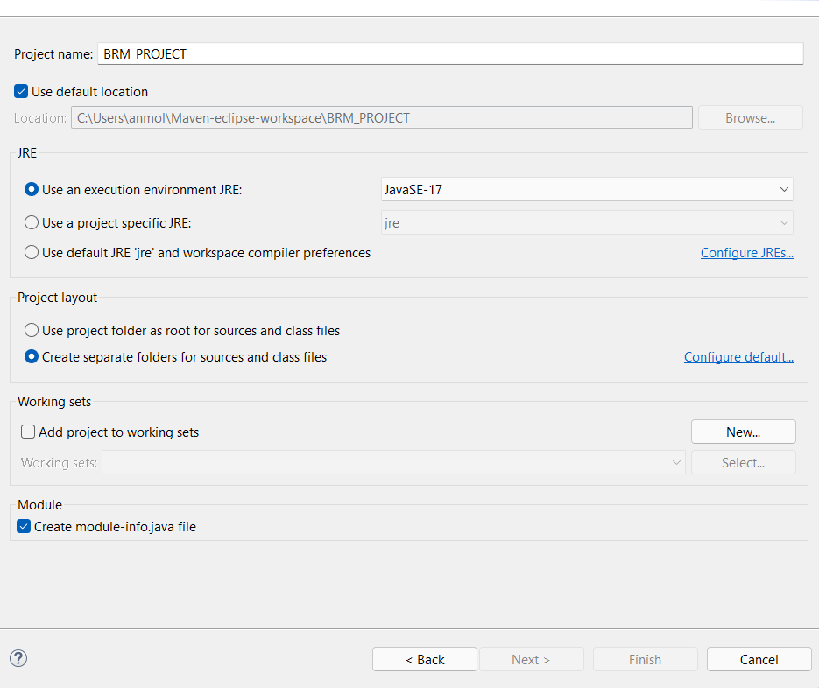

Create class:

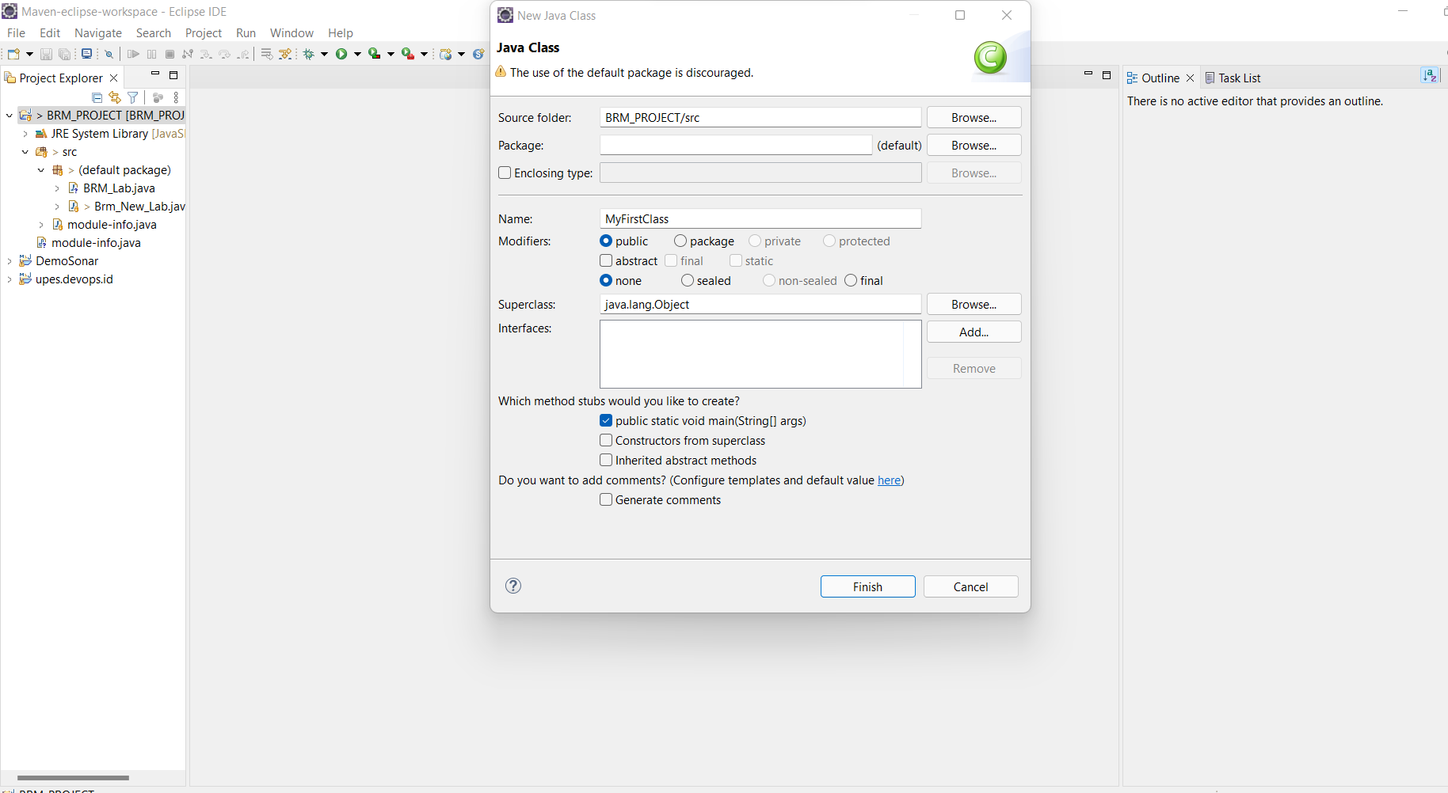

Print something on console:

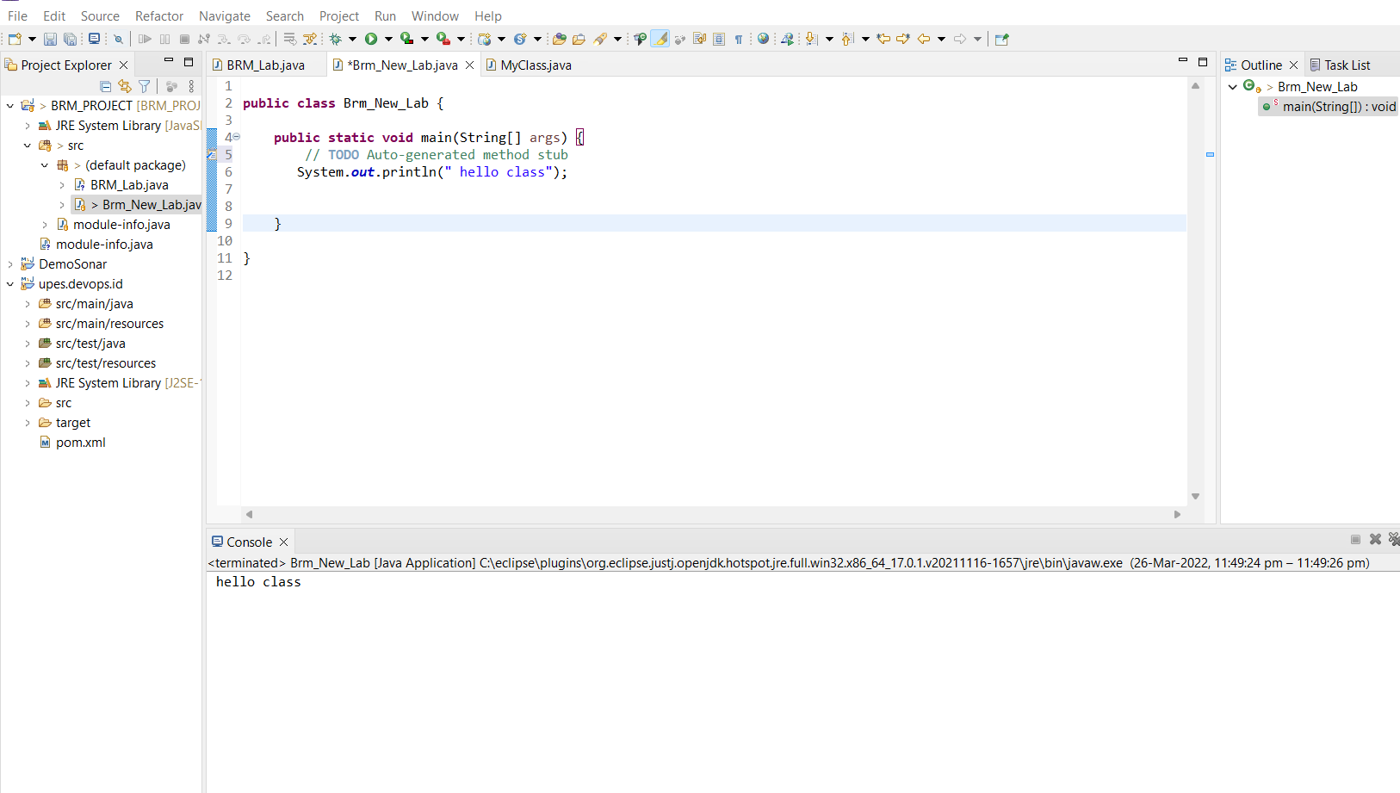

After that open, a GitHub account create a new repo and then generate tokens after that just pass a commit using eclipse.

